Practical
SUMMARY:-
The Floyd–Warshall algorithm finds the shortest distances between all pairs of vertices in a graph using a cost matrix.
Time Complexity
Case | Time Complexity
Best Case | (O(n^3))
Average Case | (O(n^3))
Worst Case | (O(n^3))

Space Complexity
(O(n^2)) - because a 2D matrix stores the distances between vertices.

Output:
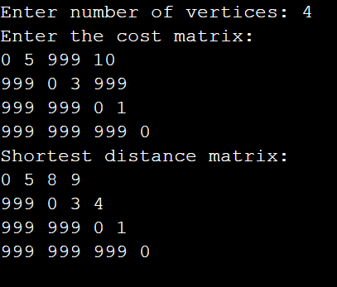

Conclusion:
Thus, the Floyd–Warshall algorithm is implemented successfully to find the shortest distances between every pair of vertices in a graph.

